# **School-Day Instructions for Parents, Families and Caregivers**

## **To view missed announcements as a parent/family/caregiver:**

To view any announcements that may have been missed, please go to either [school-day.com](http://school-day.com) or [school-day.app](https://school-day.app/) (mobile-friendly version):

In [school-day.com](http://school-day.com):

* Sign into your account
* On the main dashboard, click on the Announcements tab

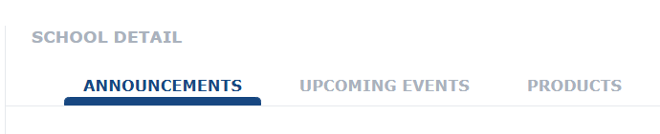

* Announcements are displayed with the most recent announcements at the top of the list; you can scroll down to view previous announcements
* To view the contents of the Announcements, click on the title

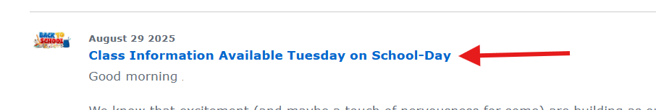

* The Announcement will open to display the full contents

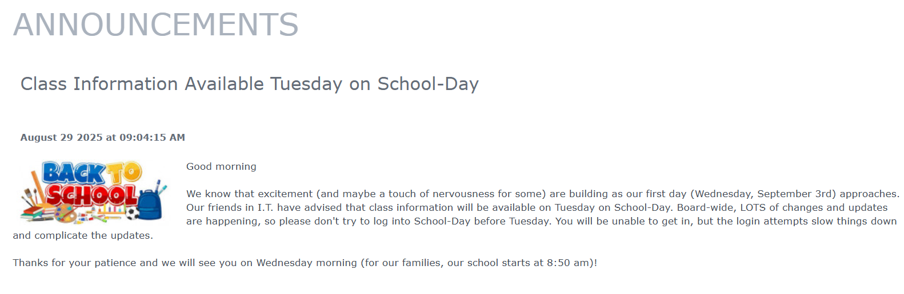

* To return to the Announcements list, click on the dashboard on the left hand side

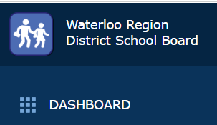

In [school-day.app](http://school-day.app) (this is the mobile-friendly version of School-Day but contains the same information)

* Sign into your account
* On the main dashboard, click on Announcements (left hand side)

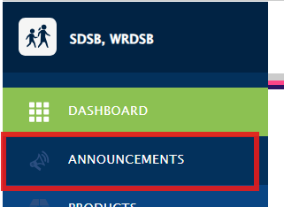

* Your screen will show a calender and the current date

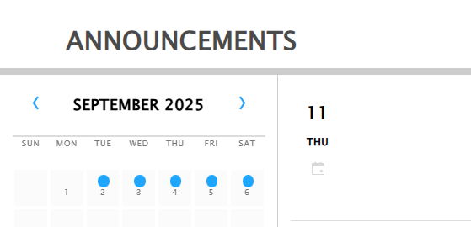

* Scroll Up and previous Announcements will be displayed

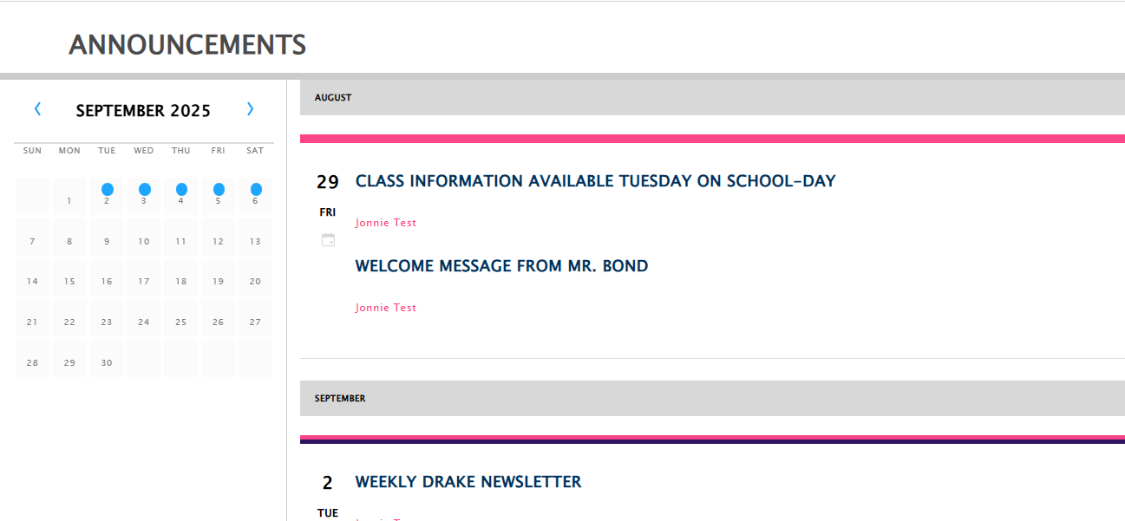

* Click on any of the Announcements titles to view the contents of the Announcement

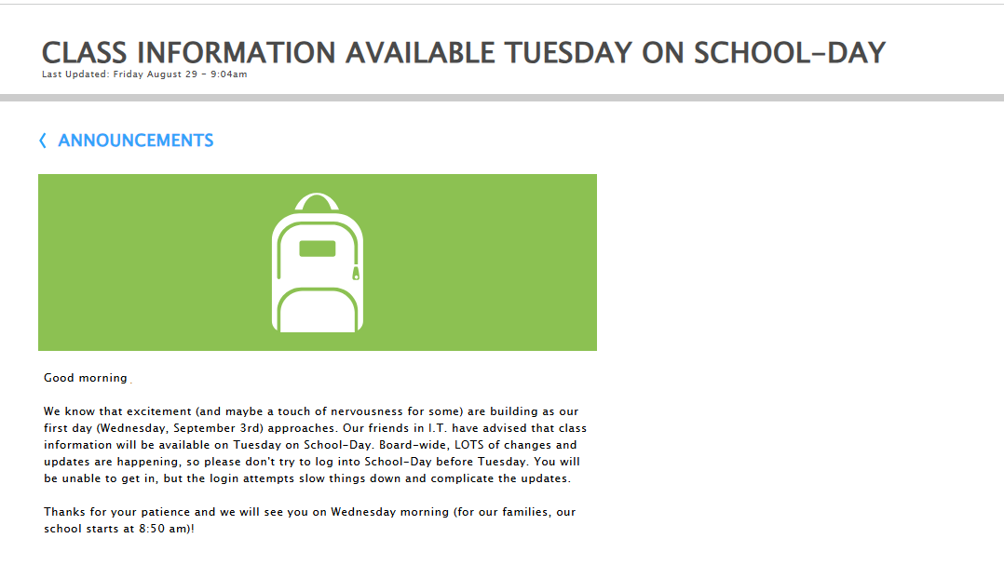

* To return to the Announcement list, click on the <Announcements link



## **To turn notifications on - Parent/Family/Caregiver Accounts**

If a user has turned notifications off, they can turn them on in either [school-day.com](http://school-day.com) or [school-day.app](https://school-day.app/):

In [school-day.com](http://school-day.com):

* Sign into the account
* Click on the cog on the bottom left corner, and Edit Profile

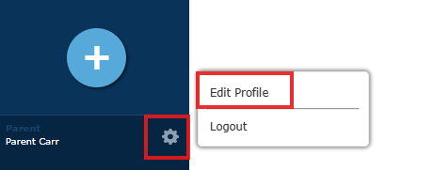

* Within the Account Information, scroll down to Email Notifications and change the setting from “Disable” to “Enable”

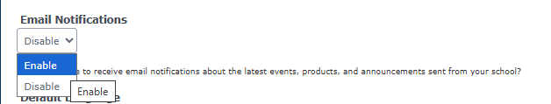

* Click “Update” to save the change

In [school-day.app](http://school-day.app)

* Sign into the account
* Click on the cog on the bottom left corner,

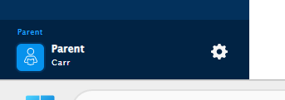

* Click “Profile”

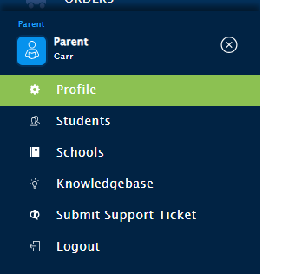

* Within “Your Profile”, scroll down to Email Notifications and change the “No” to “Yes”

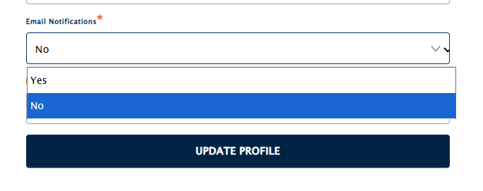

* Click “Update Profile” to save changes

## 